COMP9336 Project: Data-Driven Wi-Fi Enhancement
Zid: z5467129 Name: Chiayi Chang
- Data Collection
- Time and Location Diversity:
Location: Totally 5 Location (The data sets are labelled 1-5 from left to right.)
 | Main library | Electrical  Engineering  Building | J17 CSE building | Science and Engineering | Law library
Day | 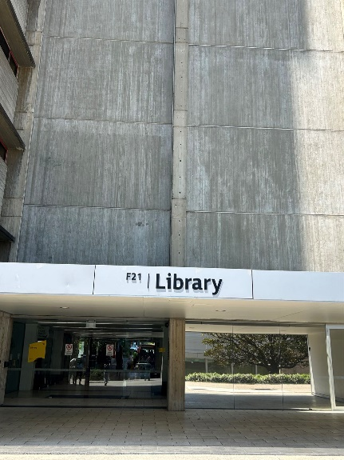 | 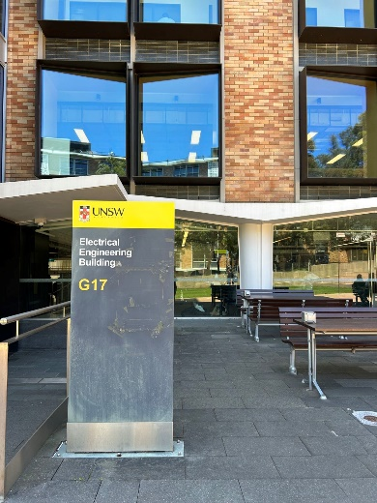 | 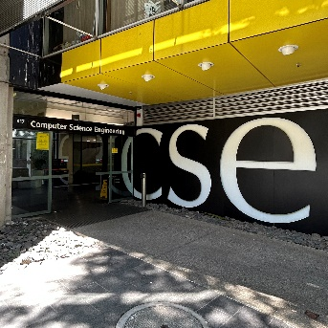 | 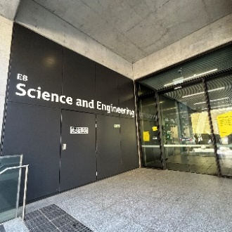 | 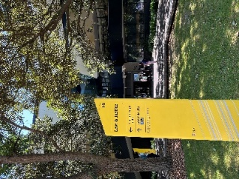
Night | 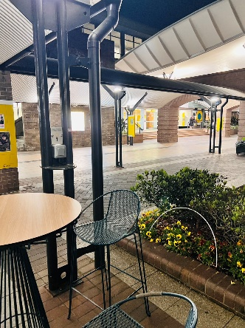 | 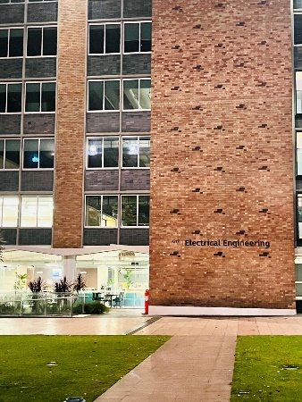 | 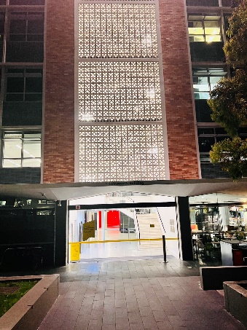 | 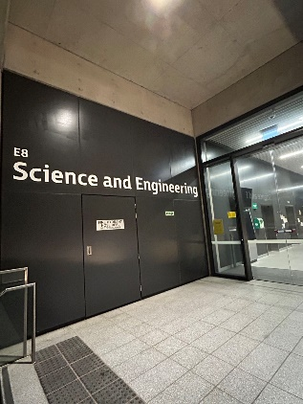 | 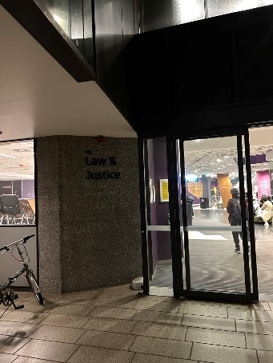
Time: Totally 4 days crossing 2 weeks
Week7 Friday(Designated as weekend),Sunday(Designated as weekend) Week8 Tuesday(Designated as weekday) Wednesday(Designated as weekday)
- Frequency and Channel Coverage:
Channel:1 6 11(2.4GHz)
Other channels seem like not busy(lower than 1%) like this threes channels, so I pick those channels for my report.
- Data Volume: every data was collect over 10 min or more than 10000 retry packet.
- Performance Analysis
- Data Processing:
The processed data I put in Clean_Wifi_data.csv, which contains all the required data, but this package is very difficult to run due to the computer's condition, so I chose to use the csv package separately to process all my data .
- Retransmission Analysis:
First, we analyze the retransmission distribution of different location between day and night.
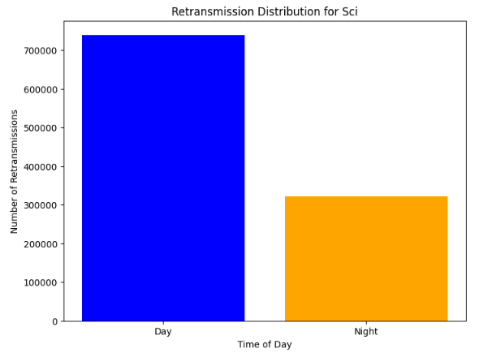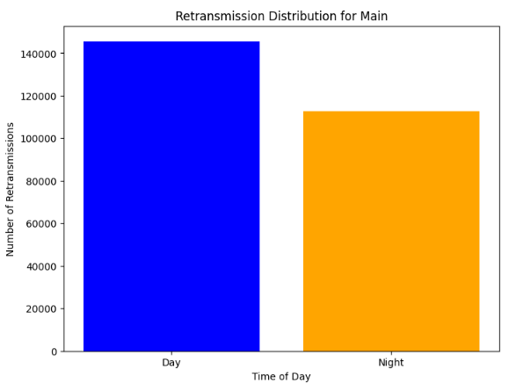
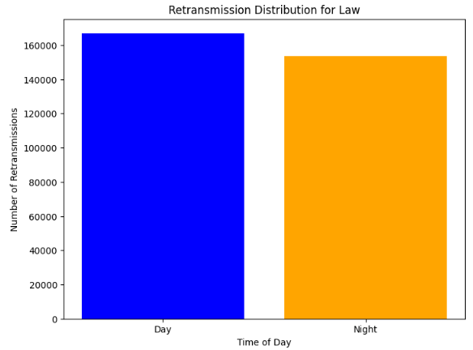
Those graphs show that the total retransmission of day and night in different locations. Law library retransmission is almost the same, I think this is because the law library is open 24 hours. Therefore, the internet use of the Law library is stable. At the same time, it is the busiest place at night. At night there is a significant change that there don’t have many people stay in EE building.
The main library also have small differences between day and night, I think the reason of the graph is because the data included weekdays and weekend. In the weekend, most of the building don’t open in the weekend so main library might have more people than other building.
For the J17CSE building there have more than 160000 data in the total dataset in the morning, and only have 80000 data at night. It shows that there don’t have many people using internet at night and The number of retransmissions is significantly higher during the day, which is associated with increased network traffic and interference.
Then, for the EE building, it has very high retransmission in the morning, because there are also a study space over there. And it is on the busiest street of UNSW.
Last but not least, the science & engineering building has the highest retransmission in the all location not only in the morning but at night, it might because there are a study center and accommodation beside the building. So, there are high retransmission in the morning and also have high retransmission at night because of accommodations. This is even higher than Law library.
Second, we can analyze the differences between weekday and weekend. 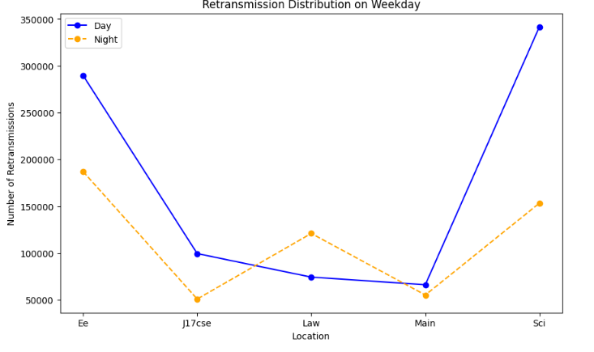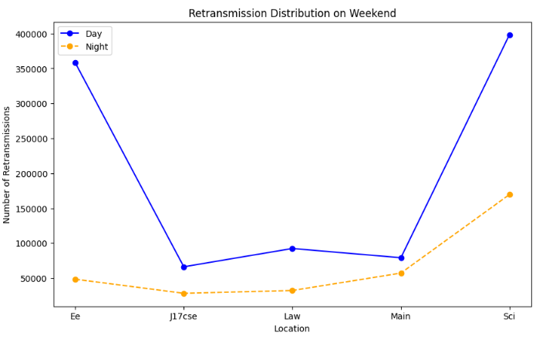
For the weekday EE and Sci locations had the highest number of retransmissions during the day, with almost 300,000 for EE and nearly 350,000 for Sci. The number of transmissions decreases significantly at night.
For the weekend, the EE and Sci locations still have many people using internet but there has low retransmission at EE building.
For j17, the law library and the main library is quit stable for both weekday and weekend. However, the number of retransmissions of j17 and main library was lower overall on weekends than on weekdays, especially during the night, indicating a decrease in network usage.
In conclusion, the number of retransmissions is generally higher during the daytime on weekdays and slightly lower on weekends, indicating a trend of reduced internet usage on weekends.
Next, the next two graph show that the difference between day and night in different location. 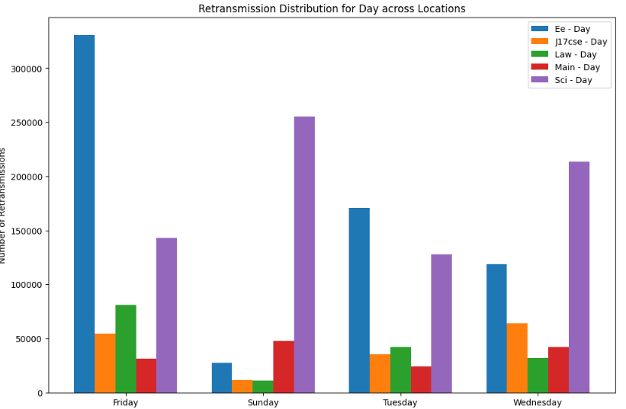
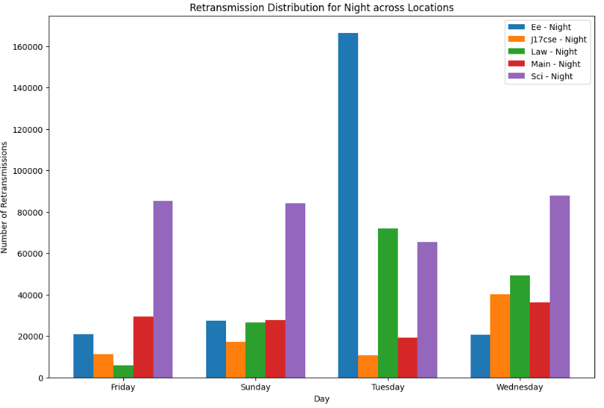
For the left graph, which show retransmission in different location in the day time. With the exception of Sundays, the EE building has a high re-transmission rate, getting first or second place almost every day. The Science Building reaches its peak on Sundays and Wednesdays. The number of retransmissions is relatively stable and low for J17CSE and Main locations.
For the right graph, which show retransmission in different location in the night time. We can see that at night, the repeat rate of the Science Building is quite high, which may be related to the fact that there is a dormitory next to it. In addition, we can see that the retransmission rate of the Law Library is relatively high except on Fridays.
Third, the graphs show the retransmission rate distribution of different locations on different channels (Channel 1, 6, and 11).
Retransmission rates for these two channels were generally higher in the locations, particularly in the EE and Sci locations. Interference is particularly noticeable on Wednesdays and Fridays, indicating that these channels have the greatest impact on high-traffic days. Whilst Channel 6 does not have as much interference as Channels 1 and 11, it still shows significant interference at the Sci and EE sites, particularly during the day and on Wednesdays.
Overall, interference on Channels 1 and 11 is more noticeable at most locations and time periods, and it is recommended that these channels be optimized or channel usage be adjusted to reduce interference.
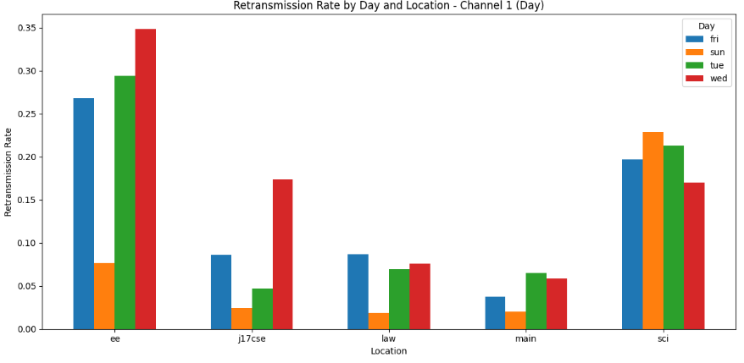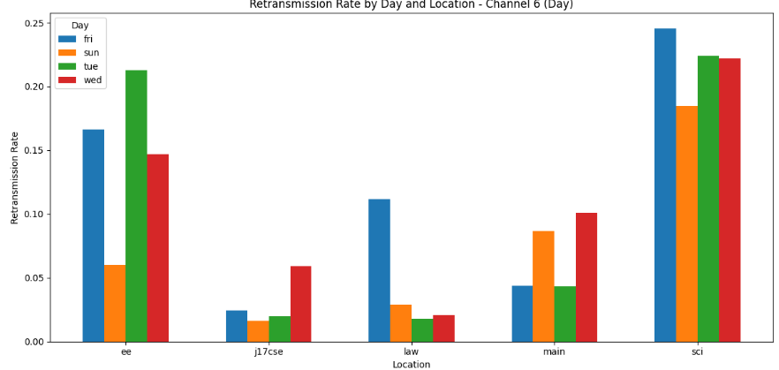
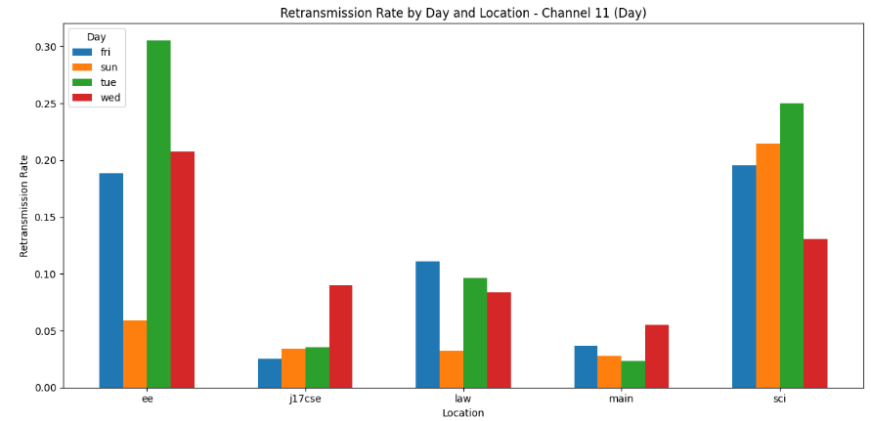
Next graph show the comparison of retransmission rates of different channels at different locations and on the same day. 1 and 11 have higher retransmission rates, particularly on Fridays, Tuesdays and Wednesdays, suggesting that these channels are at greater interruption risk on high-traffic days. Channel 6, although relatively stable, also shows a short-term increase in interference at specific locations and days . Channel usage declined over the weekend, but channels 1 and 11 still maintained high retransmission rates at certain locations.
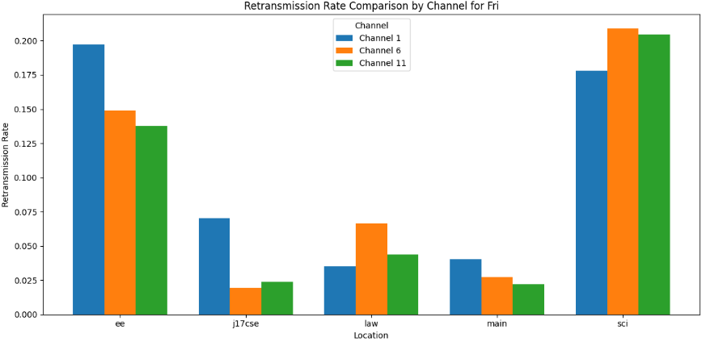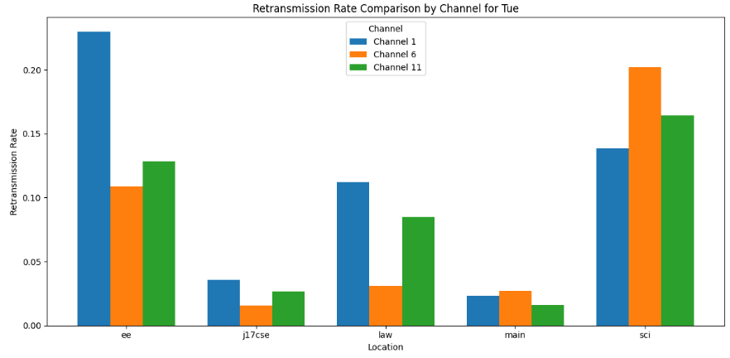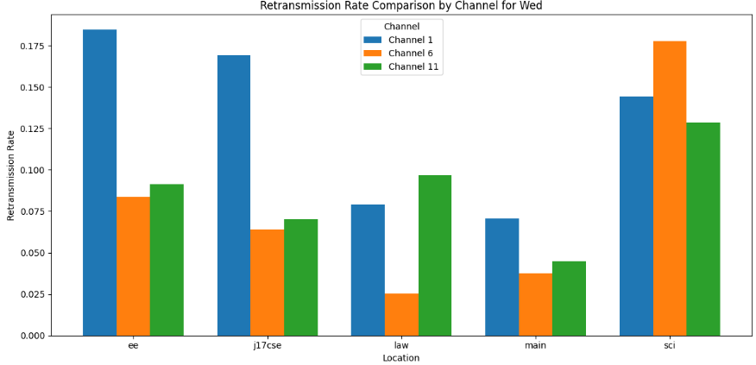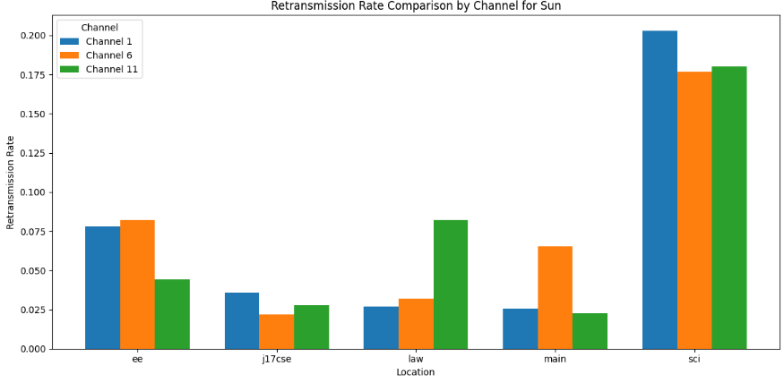
This graph shows the average retransmission rate of Channels 1, 6, and 11 during daytime and nighttime. The retransmission rates for all channels were higher during the day than at night, suggesting that network usage is higher during the day and interference is more severe. The average retransmission of channel 1 is the highest both in daytime and nighttime.

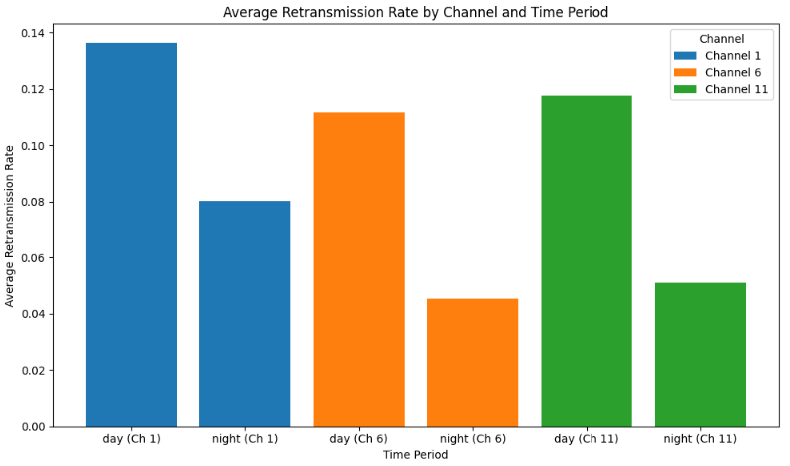
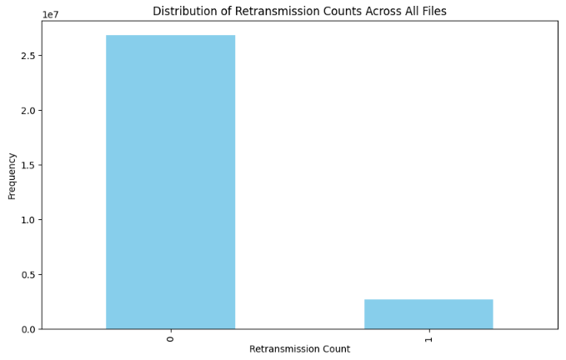
In the data I tested, there was no duplicate transfer, and most of the data was successfully transferred in a single pass, with a small number of retransmissions in a single pass.
- Network Performance Analysis:

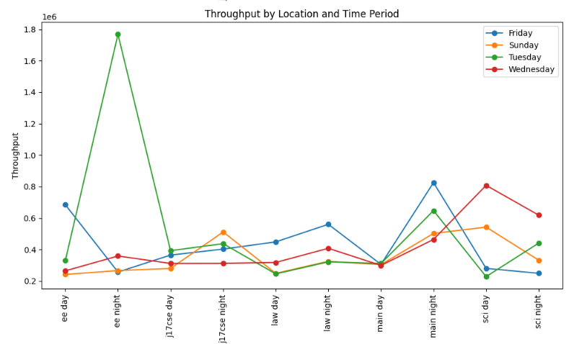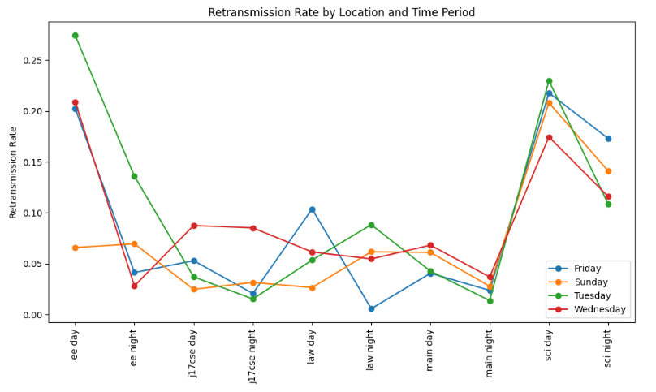
Throughput is calculated as the sum of the lengths of successfully transmitted packets divided by the total time range. I utilised the Retry field to filter successful packets and used the Length and Time fields to calculate this. The efficiency is calculated as the ratio of the length of successfully transmitted data to the total number of transmissions, again relying on the Retry field to differentiate between successful and retransmitted packets, and using the Length to calculate the effective amount of data, as well as group.shape[0] to calculate the total number of transmissions. The retransmission rate is the ratio of retransmitted packets to the total number of transmissions, and I use group.shape[0] to get the total number of transmissions.
The graphs show that throughput does not fluctuate much across locations and time periods. Except for the EE location where the throughput peaks on Tuesday night, the retransmission rate at this location is not always the strongest during this time period. This suggests that the network environment is relatively stable during this time period and supports higher data transfers despite some retransmissions. The Sci location had a higher retransmission rate during the nighttime hours when throughput was not at its highest. This may be due to the fact that the number of retransmissions at this location and time period occupied too much bandwidth, limited the effective data transmission, and thus reduced the throughput.
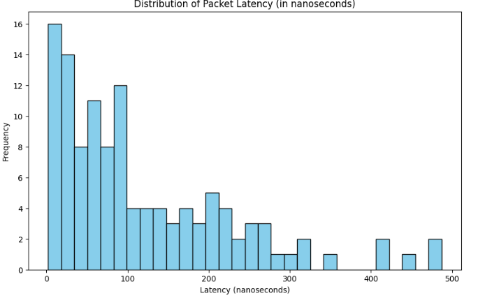
When calculating the delay, I sorted the data packets and confirmation packets by Time field and took only the first packet for each destination. Finally, the delay is presented in nanoseconds because there is basically no delay time.
The distribution of latency is right skewed, indicating that most packets are transmitted smoothly, but there are a few instances of high latency, which may be caused by network congestion at specific locations or time periods. The delay of most packets is centered around less than 100 nanoseconds, especially the highest frequency between 0-50 nanoseconds, which indicates that the delay of most packets is relatively low. A few packets have delays above 100 nanoseconds, and some even reach 500 nanoseconds. These packets may be affected by network congestion or interference, resulting in longer delays.
The average latency at night is lower than during the day at most locations, indicating that network usage is less stressed at night and transmission efficiency is relatively high. The average latency of the law library is obviously higher than the other locations, both during the day and at night, which suggests that there may be more interference in the network at this location or because its data is tested indoors.

- Machine Learning Evaluation
- Model Training and Evaluation:

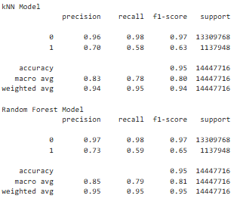
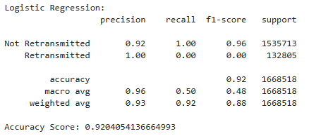

In the situation of using kNN model, Precision, Recall and F1-Score of non-retransmitted packets are 0.96, 0.98 and 0.97.It show that kNN is very stable at recognized the non-retransmission packets. For the retransmission packets, Precision, Recall and F1-Score of non-retransmitted packets are 0.7, 0.58 and 0.95. It show that kNN is hard to notice the retry packets. But because the non-retransmission packet is more than the retry one, so the accuracy of the data might not be true. However, the overall precision and recall of the model is 0.94 and 0.95.
In the situation of the Random Forest model, Precision and Recall of non-retransmitted packets are 0.97 and 0.98. It seems that similar to the result of the kNN model and much more better. For the retransmission packets, Precision, Recall and F1-Score of non-retransmitted packets are 0.73, 0.59 and 0.65. It seems like better than kNN model. The total accuary is 0.95 ,too. However,it seems like more stable than kNN model.
In the case of using Logistic regression model, the precision, recall and F1-Score of non-retransmitted packets are 0.92, 1.00 and 0.96 respectively.Basically, retransmitted packets cannot be identified. However, since the non-retransmission rate is high, the accuracy rate is also high. In fact, this model is not successful and more information may be needed.
- Model Interpretation:
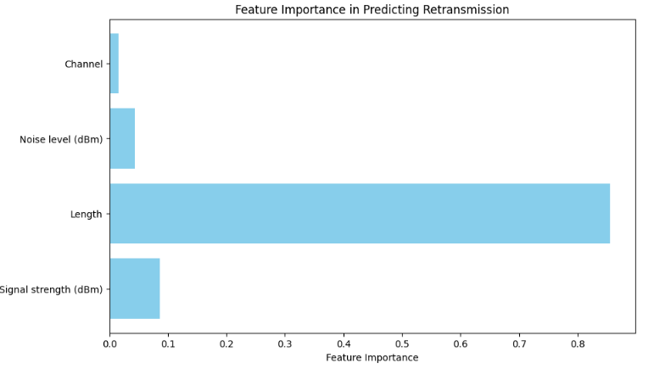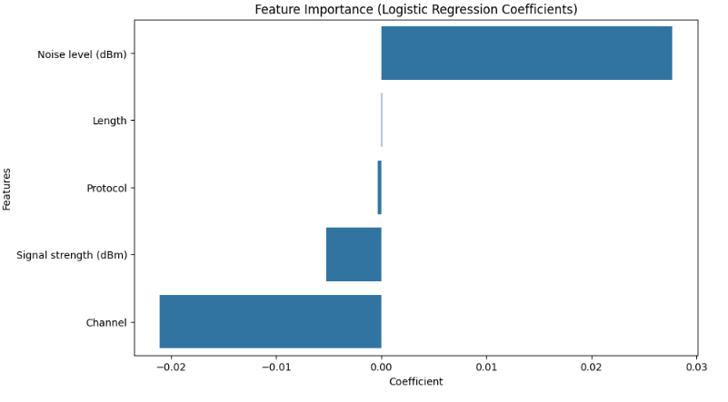
In predicting retransmission of random forest model, packet length and noise level are the most critical features, while signal strength also has some effect. These features show that the level of noise level and packet size in the network have a significant effect on retransmission.
For the Logistic Regression the noise level has the highest prediction of the feature. However, the data of this model was not accurate , it might not be the true feature for us to use.
- Protocol Enhancement Design
For the Dynamic Channel Allocation, if we let the wi-fi device scans the surrounding channel congestion regularly. When a channel is congested, the system will automatically select a relatively free channel for switching. It can decrease the competition in the channel, and decrease the retransmission of the packet. However, frequent channel switching may affect network stability, especially in fast-moving scenes. In addition, how to perform channel switching without interfering with other devices is also an issue to be considered.
For the AI-driven traffic prediction and pre-allocation, I choose the research on IEEE(In the reference)which use machine learning techniques to predict network traffic and pre-allocate it to reduce retransmission during congestion. Because AI models can learn network traffic patterns, as we are doing in this project, and reserve bandwidth resources in advance during high-demand periods to avoid retransmission caused by unexpected traffic. However, this method requires real-time data collection and analysis, as well as strong computing power. Therefore, the price may be relatively high, and it is difficult to be included in everyone's system but suitable for public Wi-Fi network.
References:
https://www.comsoc.org/publications/journals/ieee-jsac
Additional pictures to support my report:
